Lanthanum doped hafnium oxide: a robust

ferroelectric material

*Uwe Schroeder1,*, Claudia Richter1, Min Hyuk Park1, Tony Schenk1, Milan Pešić1, Michael Hoffmann1, Franz P. G. Fengler1, Darius Pohl2, Bernd Rellinghaus2, Chuanzhen Zhou3, Ching-Chang Chung3, Jacob L. Jones3, and Thomas Mikolajick1,4*

*1*NaMLab gGmbH, Noethnitzer Straße 64, 01187 Dresden, Germany   
*2*IFW Dresden, Helmholtz Straße, Dresden, Germany   
*3*Department of Materials Science and Engineering, North Carolina State University, Raleigh, North Carolina 27695-7907, USA   
Analytical Instrumentation Facility, College of Engineering at North Carolina State University, Raleigh, North Carolina 27695 -7531, USA   
*4*Chair of Nanoelectronic Materials, TU Dresden, 01062 Dresden, Germany

**Supplementary Information**   
 The structure of a 10 cat% La:HfO2 sample is characterized at different annealing temperatures. Figure SI 1 shows the temperature dependence of XRD patterns of the 10 cat% La:HfO2 sample in a temperature range of 25 to 900 °C. XRD data shows that the 10 cat% La:HfO2 sample exhibits an orthorhombic/tetragonal/cubic phase in a temperature range between 25 – 700 °C and an increase of the monoclinic intensity for temperatures >700°C during a slow temperature ramp of 0.2 °C /s. The according TOFSIMS results before and after the slow temperature ramp in the XRD tool is shown in Figure SI 5 ( a) before and b) after XRD measurement). In Figure SI 2 the

S1

change of the coercive field Ec and wake-up behavior is plotted for different annealing temperatures. Ec is almost constant whereas the wake-up behavior clearly improves for higher anneal temperatures. An 800 °C anneal of the 10 cat% La sample results in a polycrystalline film with a grain radius of 30±20 nm as determined by top-view SEM (Figure SI 3). Furthermore, the broadening of the hysteresis is plotted during field cycling until 104 cycles at 4MV/cm as a function of the La content (Figure SI 4).

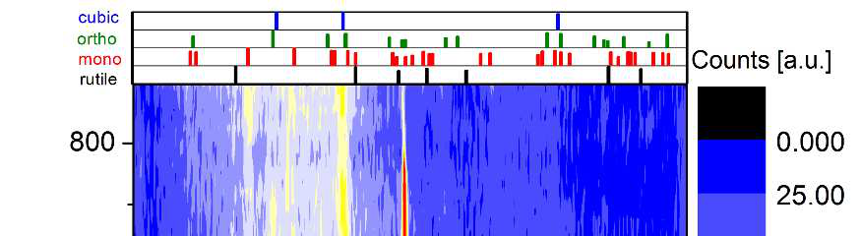

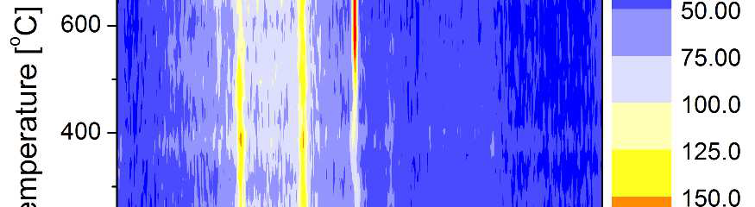

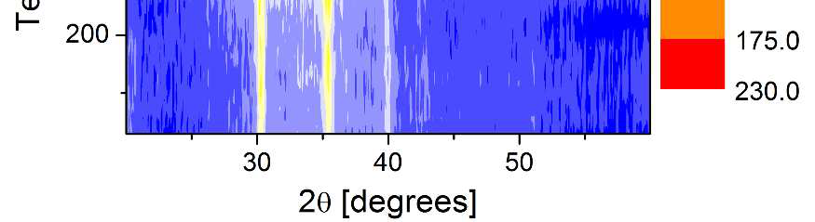

**Figure SI 1:** Temperature dependent XRD

pattern for a 10 cat% La:HfO2 sample during

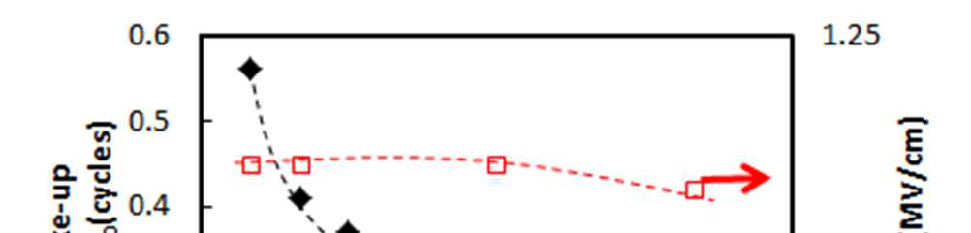

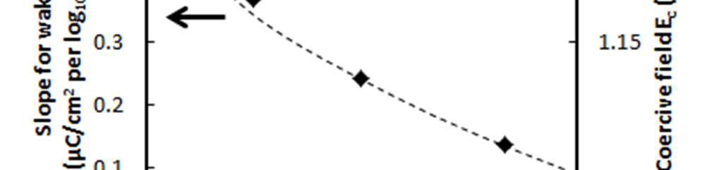

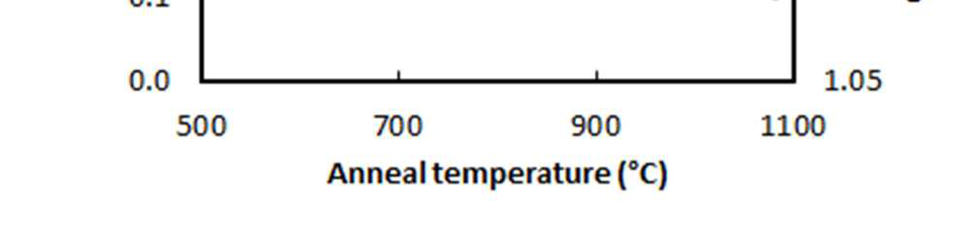

**Figure SI 2**: Change of the wake-up slope and

coercive field as a function of anneal

annealing from 25 to 900 °C with reference temperature.

tick marks (*P*42/*nmc*  tetragonal, *Pca*21

orthorhombic, *P*21/*c* monoclinic phases of

HfO2 and *P*42/*mmm* rutile phase of TiO2.

S2

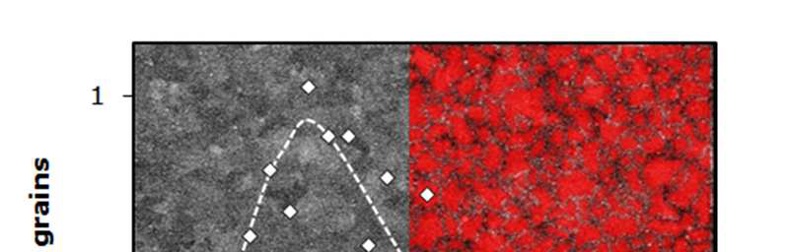

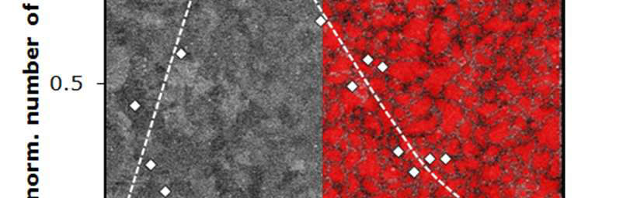

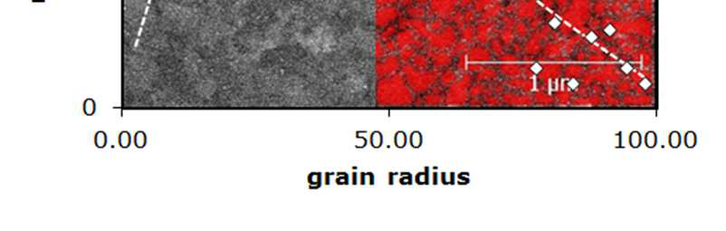

**Figure SI 3:** Top down SEM image and grain size determination by Gwydion software (watershed method) of a 10 cat% La sample after anneal at 800°C. The resulting number of grains as a function of radius is normalized to the maximum value.

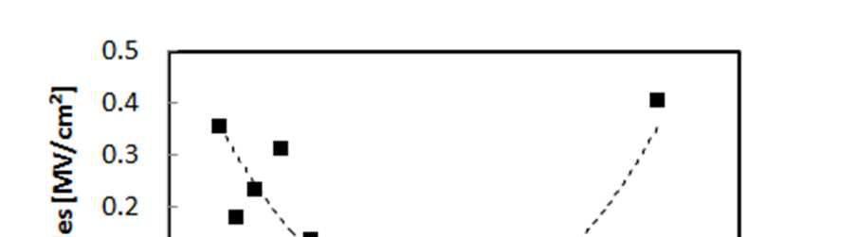

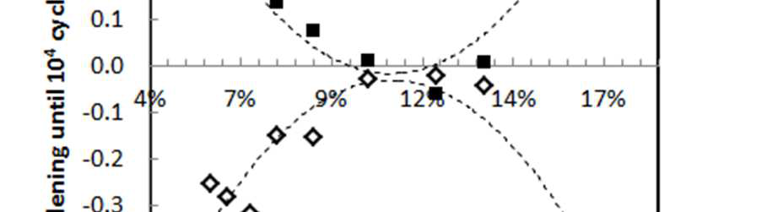

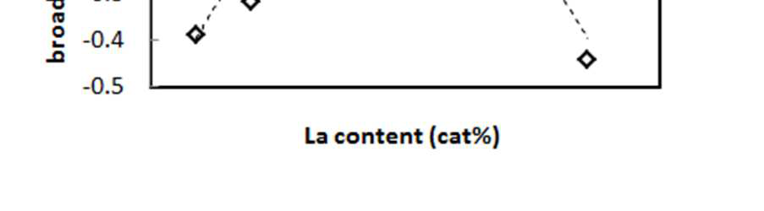

**Figure SI 4:** Broadening of the hysteresis curve for different La content caused by ‘de-pinching’. The change is determined as the difference between the positive (filled) and negative x-axis intersection values (open symbols) of the hysteresis after 104 cycles vs. the pristine case.

a) b)

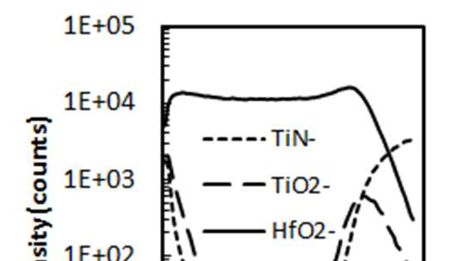

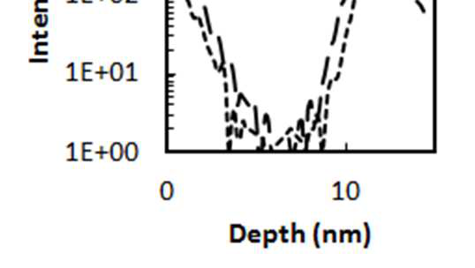

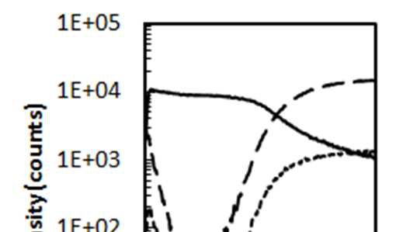

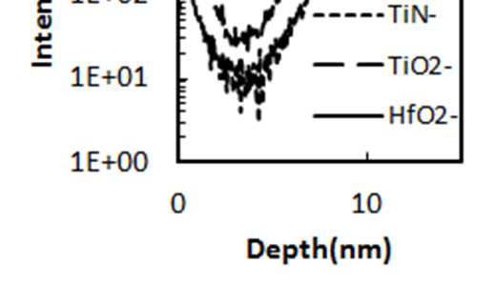

**Figure SI 5:** a) TOF-SIMS after 800°C 20s anneal b) TOF-SIMS after slow 0.2K/s ramp during temperature dependent GIXRD measurement in Figure SI 1.

S3

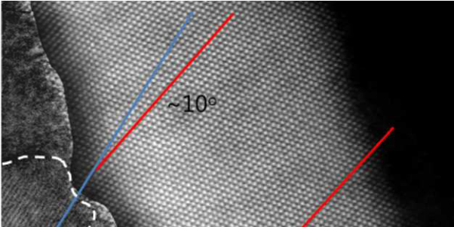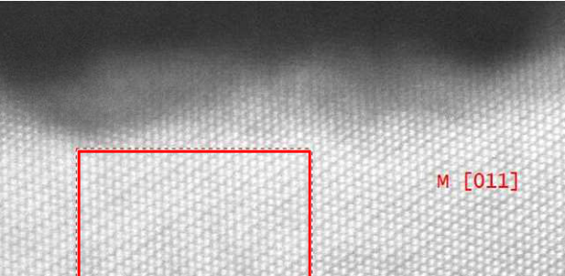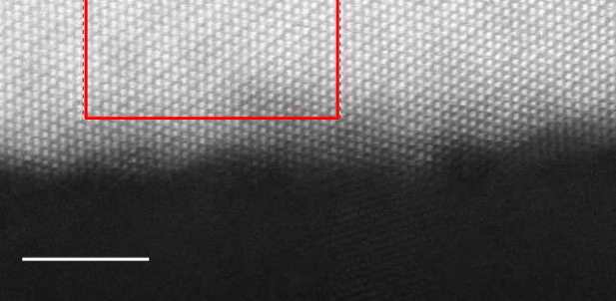

An orientation relationship between TiN substrate and a HfO2 grain was detected in a TEM image of a 10 cat% La:HfO2 capacitor structure (Figure SI 6a) and example of monoclinic/orthorhombic phase portion (Figure SI 6b). In addition to 10 cat% La:HfO2 capacitor structures as shown in the main manuscript, 16 cat% La:HfO2 samples are analyzed by TEM and a [001]-zone of the La:HfO2 sample is verified (Figure SI 7).

|  |  |  |
| --- | --- | --- |
| **a)** | **b)** |  |
|  | 5 nm |  |
|  |

Figure SI 6: STEM cross section image of a 10 cat% La:HfO2 capacitor structure: a) Orientation relationship between TiN substrate (contrast enhanced) and HfO2 grain. b) monoclinic [011] or orthorhombic [101]-zone of the La:HfO2 region.

Figure SI 7: STEM cross section image of a 16 cat% La:HfO2 capacitor structure with [001]-zone of the La:HfO2 region. The phase could be orthorhombic or monocline.

As already mention in the main manuscript, for characterization of the defects in the HfO2 layer the thermally stimulated depolarization current technique (TSDC) is applied. Initially, the sample is polarized at 380°C with an applied electric field and rapidly cooled down while the same electric field is still utilized to freeze possible diffused charges in their local and energetic positions. During slow heating with 0.2 K/s the depolarization current is determined suggesting S4

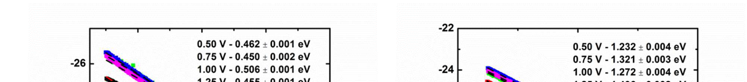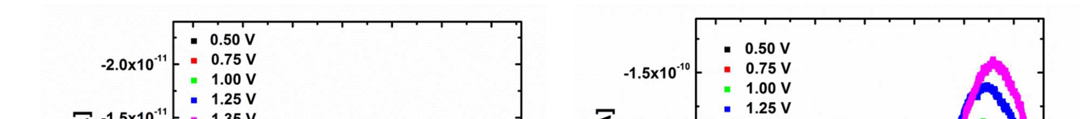

two current maxima at about 290 °C and 320°C. For peak separation the thermal cleaning method was applied. The relaxation current peak at 350 °C was solely measured by poling the sample at 350 °C, cooling it down to 250 °C while applying the same poling voltage and holding the temperature without application of a bias voltage to allow relaxation of charges with lower activation energy for 800 s (Figure SI 8a). The current peak at 275 °C was separated by poling at only 200°C, which does not allow charges with higher activation energy to move (Figure SI 8b). The activation energies were determined by using the initial rinse method as 0.45 – 0.51 eV (Figure SI 8c) and 1.23 – 1.46 eV (Figure SI 8d) depending on the applied poling voltage. This function was fitted to the measurement data for extraction of the amount of mobile charge carriers per volume for both peaks (Figure SI 7e and f). Values of 0.35% singly and 0.05% doubly charges oxygen vacancies are about a factor of 2 higher compared to reported values for Hf0.5Zr0.5O2.

a) b)

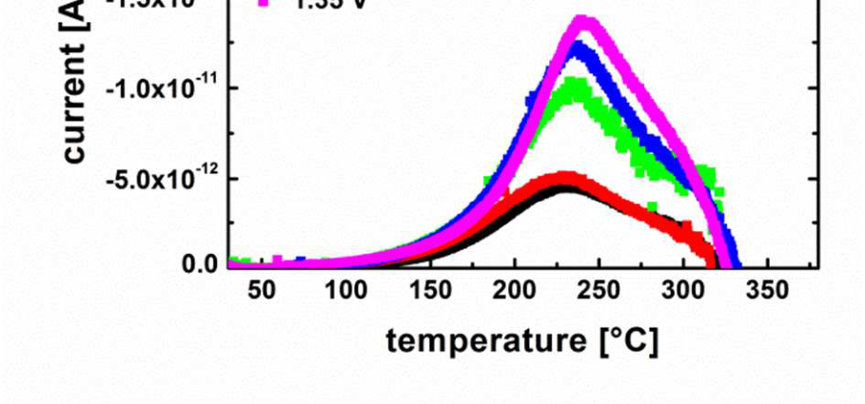

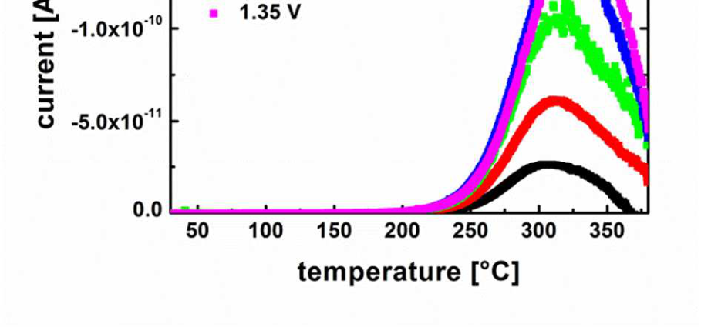

c) d)

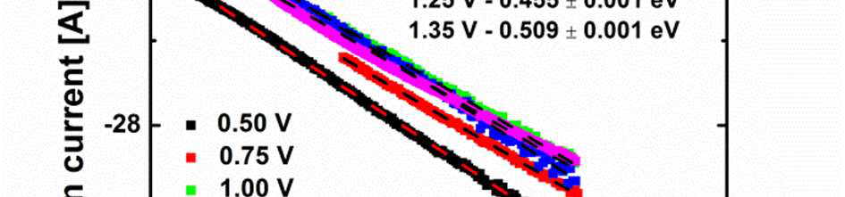

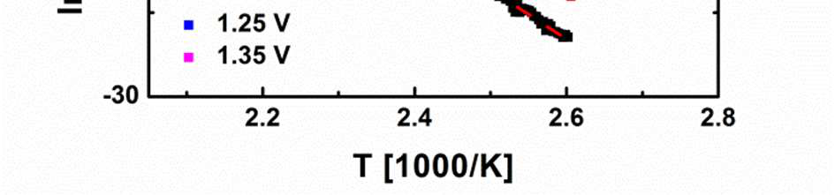

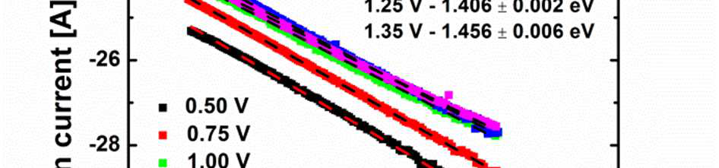

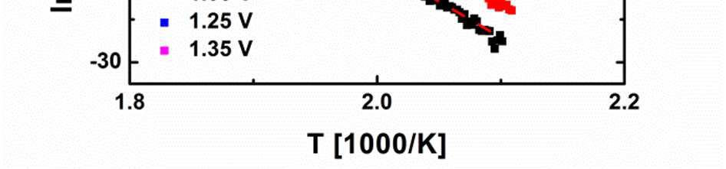

S5

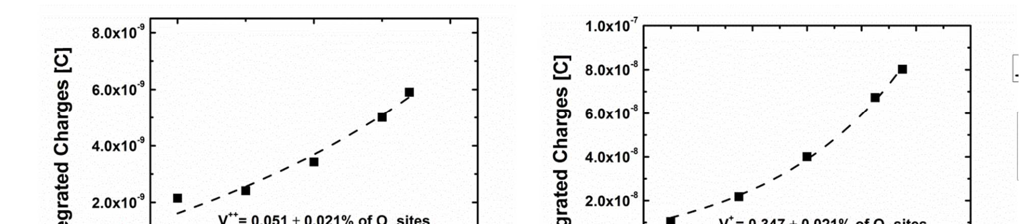

e) f)

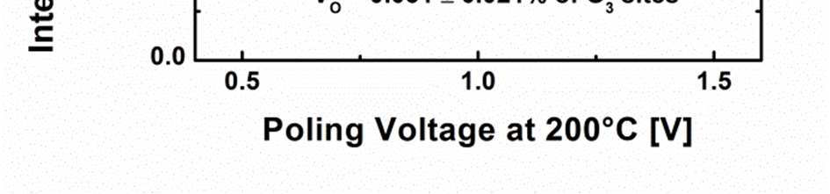

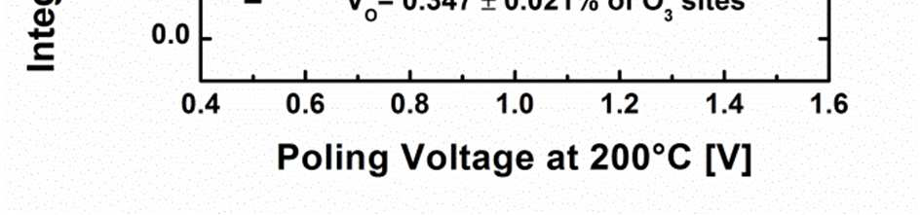

Figure SI 8: Thermally stimulated depolarization current measurement of 20 nm thick TiN-La:HfO2-TiN capacitors with 10 cat% La dopant concentration a) after poling with the given voltages (0.5 V-1.35 V) for 800 s at 320 °C and thermal cleaning at 250 °C for 800 s and b) after poling with the given voltages (0.5 V-1.35 V) for 800 s at 200 °C using a ramp rate of 0.2 K/s and Arrhenius plots with extracted activation energies using thermal rinse method for a) and b). Extracted charges of the depolarization current measurements e) after poling with the given voltages for 800 s at 320 °C and thermal cleaning at 250 °C for 800 s as shown in c) and f) after poling with the given voltages for 800 s at 200 °C using a ramp rate of 0.2 K/s as shown in d).

S6